**ENEA TEAM**

Our project tried to solve the reverse gear challenge for a Venus’ rover.

*What kind of problems do we find on Venus?*

High temperature, about 450° C, everywhere on the surface at anytime and the presence of sulfuric acid are the main problems we have to face when we want to stay for a long period of time on the surface of the planet.

<https://solarsystem.nasa.gov/planets/venus/overview/>

*What solutions have we adopted?*

We decided to use the Stainless Steel 316L that has both a high melting point temperature and it’s resistent to corrosion. This material was used for all of our parts.

It is a well known material with a density of 8 g/cc, resistent to high stresses and doesn’t expand too much at Venus’ temperatures.

<https://en.wikipedia.org/wiki/SAE_316L_stainless_steel>

<https://www.researchgate.net/figure/Stress-Strain-Curve-AISI-316L-Stainless-Steel-500C_fig3_38005123>

*What problems did we have to overcome for the gearbox?*

An input shaft with a fixed rotationary verse, high torque-low rpm, less parts possible and avoiding linear sliding friction as much as we could.

Also the output shaft had to have at least an 85% of efficiency and could be able to go reverse when an input is given.

All of the above inside a 300cm cube under 50 Kg.

*The core of our project*

In order to be able to have both forward and reverse on our output shaft we used a planetary gear with only 3 planet gears and a carrier that connects those gears.

The carrier is the main part of this mechanism.

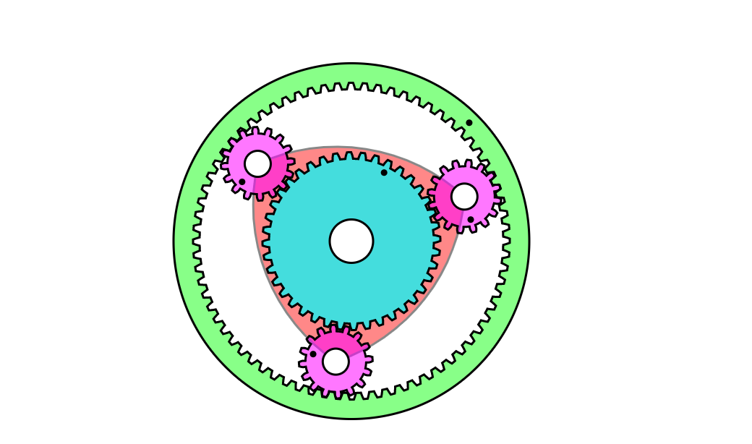We made it stay still and while it does so the planets only rotate on their axes leaving the sun gear transfer its torque to the ring gear in the opposite direction.

We estimated a loss of 10% of the torque due to the presence of the planets gears, all of the dimensions were calculated from a planetary gear simulator and adapted to our forces.

The forces on the gears teeth are transfered to the others gears with the same intensity, loss due to friction have been already talked about before, but the total torque is also dependent on the angular velocity.

<https://en.wikipedia.org/wiki/Epicyclic_gearing>

<http://www.thecatalystis.com/gears/>

*What if we wanted to change direction?*

When an input is given thanks to a sliding pin, a mechanism of hinges pushes our carrier piece to our input shaft making them mating, now our carrier and planets gears rotate in the same direction and the ring is spinning in reverse.

When the input pin returns to its nominal position the carrier detach from our input shaft and return to it’s original position with the planets fixed onto their axesof rotation.

*Could we have used different approaches?*

We first designed a mechanism that used magnets to transfer the motion of the input shaft in the reverse configuration to our planets and when the sliding pin returned to it’s normal position made the magnets structure move, in a similar way to the one described before, to its sleeping position that fixed the planet gears as already explained.

We even found the right material, samarium-cobalt, but we were unsure of the forces transfered trough it to the planets. We also run into some problems with the constraints for its movement.

<https://en.wikipedia.org/wiki/Samarium%E2%80%93cobalt_magnet>

*Final considerations*

We made some tests on MATLAB in order to validate our calculations and assumptions, made a CAD drawing of the mechanism and uploaded our material on Github at this link:

We calculated a weight of 12 Kg circa and a containment cube of 200 cm, the forces on the all our components were ok and far away from the plastic deformation treshold.